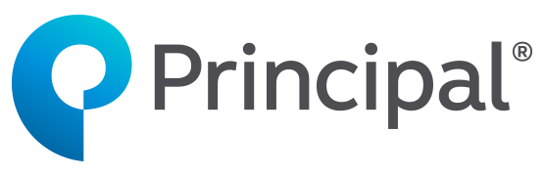

SEMINAR TOPIC:
Money 101: Where do I start?
Participants just starting out in their career or working to better understand their finances, setting up for success to protect themselves, and focusing on their long-term goals

DATE | TIME
Friday, July 23rd, 2021 | 11:00 AM ET
How to join the WebEx Meeting:

Access Web address: | pfg.webex.com
Meeting Number: | 130 988 2481
Meeting Password: | abc123

Select one of the following audio options:

- Call Using Computer and select Connect Audio
or
- I Will Call In using the information below

Toll-Free Number: | 866-205-5379
Access Code: | 130 988 2481

You may also join the audio portion only calling the toll-free number above inputting the access code.

WebEx capacity is limited to 1000 attendees per meeting.
Need WebEx Assistance? Click here

