GREAT COMMISSION MINISTRIES

TntMPD Data Import
Existing TntMPD User Documentation
Version 0.0.1 – Draft

John Abassian
Last Updated: 5/9/2012

Introduction
This document is aimed at constituents already taking advantage of TntMPD, and has some data in their local TntMPD database. If you have never used TntMPD, please refer to the First Time User document.
Until you are familiar and comfortable with the data import process, it might be wise to backup your existing TntMPD database before you start. You can do that by clicking on the “File” menu, and choosing the “Backup…” option.
Contents
- Importing GCM TntMPD DataSync file ………………………………………………………… 3
- Importing GCM TntMPD Donor information ………………………………………………... 9
- Importing GCM TntMPD Gift information ……………………………………………………. 12

Importing GCM TntMPD DataSync file

The GCM TntMPD DataSync file is the easiest and fastest way to sync all of your donor and gift information in one easy step. Unless you specifically want to update only one of the two, always use the DataSync file.

- Begin by logging into your GCM Staff account at
https://www.gcmstaff.net

- Click on the “Download TntMPD DataSync File” button to download your personal GCM TntMPD DataSync file. This file is created the moment you click the button, so it will always have the most up to date data.

- TntMPD allows you to setup automatic tasks for newly inputted data. If you are taking advantage of this feature, and would like to have tasks created for all your GCM imported gifts, then skip to step 4.

If however, you would not like to have tasks created for all your GCM imported gifts (it includes all gifts ever received, and tasks on old gifts can be unnecessary), you can temporarily disable automatic task creation in the options:

- Select Tools in the top menu bar, and click on “Options” [Figure a1].
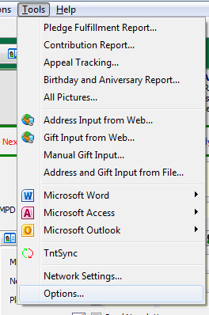
Figure a1 – Tools > Options
- In the Options dialog, select the “Gifts” tag and uncheck the “Enable Automatic Actions for New Gifts” option [Figure a2].
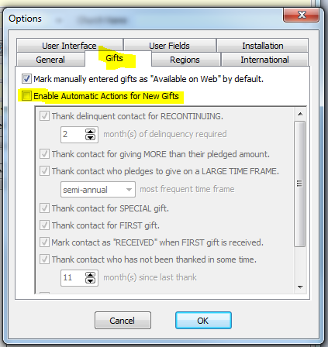
Figure a2 – Automatic Actions for New Gifts

- If your TntMPD installation was associated with .tntmpd file types, you can simply double click the downloaded file.
Otherwise, in the TntMPD program, click on Tools (in the top menu bar) and select “Address and Gift Import from File,” and browse to your downloaded file [Figure a1].
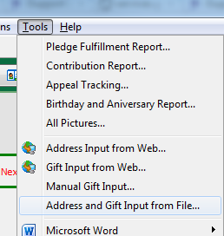
Figure a1 – Address and Gift Input from File

- You might be prompted to find the matching country from a drop down. Select the correct option and click “OK” [Figure a2].
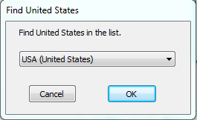
Figure a2 – Find Country Window

- TntMPD will analyze the DataSync file and present you with a summary view [Figure a3] which highlights the number of contacts that will be added to your TntMPD database, the gifts associated with those contacts, the total amount of those gifts, and the dates of the oldest and most recent gifts.
To sync GCM data with your existing data, make sure you check the “Try to match new accounts with existing contacts” option.
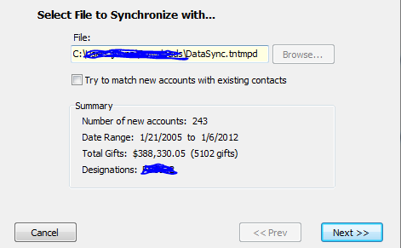
Figure a3 – DataSync Summary

- After clicking “Next” on the previous window, TntMPD will present you with a screen to try and match the GCM contact with your existing contacts. You will be presented with the screen for each record in your GCM sync file. This is a lengthy process, but you only have to do it once!

This window [Figure a4] will contain a list of contacts that have information (name, address, etc) similar to the new contact. If the contact already exists, then select the correct match and press the “Yes” button.
Otherwise, click on “No Match,” and a new record will be created.

If TntMPD cannot find a close match, it will present you with the full list of your contacts to choose from.
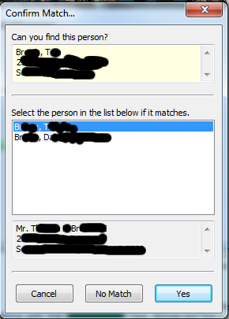
Figure a4 – Confirm Match Window

- When matching contacts is complete, you will have the opportunity to customize which contacts to add to your TntMPD database. By default, all contacts in the DataSync file will be imported. Clicking “Next” on this screen will add all your selected donors to your contact list.

- The next screen gives you the opportunity to customize which gifts will be added to your TntMPD database. Like contacts, all gifts will be imported by default. Clicking “Next” on this screen will show you a summary of the gifts to be synced [Figure a3]. Click on “Sync” to finish adding the gifts.

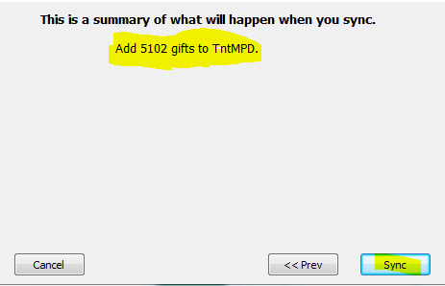
Figure a5 – DataSync Gift Summary

- This step is the reversal of step 3; if you skipped step 3, then you may also skip this step.
To re-enable automatic tasks after you have imported all your gifts:
- Select Tools in the top menu bar, and click on “Options” [Figure a1]
- In the Options dialog, select the “Gifts” tag and check the “Enable Automatic Actions for New Gifts” option [Figure a2].

That’s it, you’re done!

Importing GCM TntMPD Donor information

The donor information sync file is used to update your donor contact information with the most up-to-date information on our database. This file will sync your donor information only; gift information will not be updated!
For first time import, we suggest using the DataSync file.

For the most part, the process of importing Donor information is identical to importing a DataSync file.

- Begin by logging into your GCM Staff account at
https://www.gcmstaff.net

- Click on the “Download Donor Data” button to download your personal GCM TntMPD Donor information sync file. This file is created the moment you click the button, so it will always have the most up to date data.

- If your TntMPD installation was associated with .tntmpd file types, you can simply double click the downloaded file.
Otherwise, in the TntMPD program, click on Tools (in the top menu bar) and select “Address and Gift Import from File,” and browse to your downloaded file [Figure b1].
Figure b1 – Address and Gift Input from File

- You might be prompted to find the matching country from a drop down. Select the correct option [Figure b2].
Figure b2 – Find Country Window

- TntMPD will analyze the Donor sync file and compare it against the existing contacts in your TntMPD database. You will be presented with a summary screen that shows you the number of new contacts to be imported [figure b3]. Please note that this does not indicate the number of modified accounts, if the number of new accounts is 0, the sync file may still contain updated data for your existing contacts!

If you already have GCM donor information in your TntMPD database, please check the “Try to match new accounts with existing contacts” box [Figure b2] to insure no duplicate contacts are created.
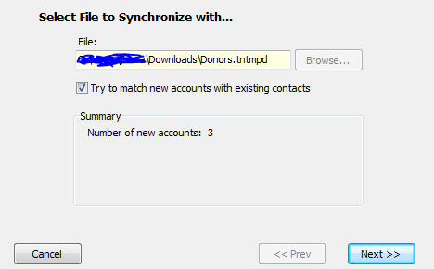
Figure b3 – Sync File Summary

- Pressing “Next,” you will be prompted with a “Confirm Match” window for each new contact [Figure b4]. This window will contain a list of contacts that have information (name, address, etc) similar to the new contact. If the contact already exists, then select the correct match and press the “Yes” button.
Otherwise, click on “No Match,” and a new record will be created.

If TntMPD cannot find a close match, it will present you with the full list of your contacts to choose from.
Figure b4 – Confirm Match Window

- Clicking “Next” on the previous window, you will have the opportunity to customize which contacts to add to your TntMPD database. By default, all contacts in the Donor sync file will be imported. Clicking “Next” on this screen will add all your donors to your contact list.
That’s it, you’re done!

Importing GCM TntMPD Gift information

The gift information sync file is used to update your MPD data with the most up-to-date information on our database. This file will sync your gift information only; donor information will not be updated!
For first time import, we suggest using the DataSync file.

For the most part, the process of importing gift information is identical to importing a DataSync file.

- Begin by logging into your GCM Staff account at
https://www.gcmstaff.net

- Click on the “Download Gift Data” button to download your personal GCM TntMPD gift information sync file. This file is created the moment you click the button, so it will always have the most up to date data.

- If your TntMPD installation was associated with .tntmpd file types, you can simply double click the downloaded file.
Otherwise, in the TntMPD program, click on Tools (in the top menu bar) and select “Address and Gift Import from File,” and browse to your downloaded file [Figure c1].
Figure c1 – Address and Gift Input from File

- TntMPD will analyze the Gift sync file and compare it against the existing gifts in your TntMPD database. You will be presented with a summary screen [Figure c2] that shows you the number of gift records in the sync file. Please note that this does not indicate the number of new or modified gifts, but a total number of all gifts in the sync file.

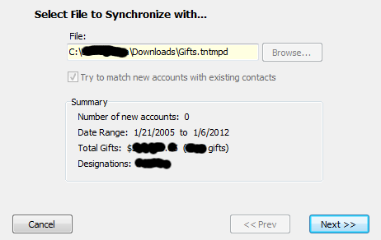
Figure c2 – Gift Import Data Summary Screen

TntMPD will automatically associate the gifts with the donor who gave them.

- Clicking “Next,” TntMPD will scan all the gift records in the sync file and compare them against your local TntMPD database. If it finds no updated gifts and no new gifts, TntMPD will tell you that you have successfully synchronized your gift information [Figure c3].
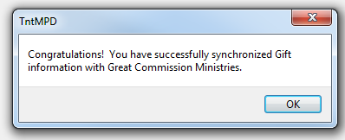
Figure c3 – Successful synchronization
If TntMPD finds updated gift information while scanning the gift sync file, it will automatically adjust the information and present you with a confirmation dialog [Figure c4].

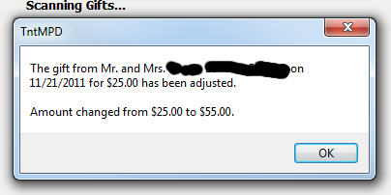
Figure c4 – Updated Gift Information

And finally, if TntMPD finds new gifts that do not exist in your TntMPD database, it will present you with list of all new gifts to be imported. At this point, you have the option to uncheck any gifts that you do not want to add to your TntMPD database; by default, all new gifts are checked and will be imported.

- Pressing “Next” will give you a summary of what TntMPD is ready to do. It should simply state the number of new gifts it is going to add to your local database [Figure c5].

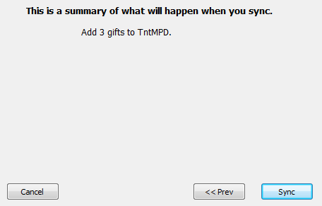
Figure c5 – Gift Import Sync Summary Screen
- Now all you have to do is click on the “Sync” button. TntMPD will add the selected gifts to your local database, and you will be presented with the successful synchronization confirmation box [Figure c3].

That’s it, you’re done!

